Magnetic Analysis

The permanent magnet assembly is attached to the centre of the target shaft and this assembly is responsible for interacting with the stator coil field to produce the force which accelerates the target into and out of the ISIS beam. A possible reason for excessive lateral forces on the bearing shaft interface could be an imbalance in the magnet field strength produced by these magnets. Possible causes of such an imbalance could be inadequate initial magnetization by the manufacturers, incorrect assembly or partial demagnetization via heating during normal operation. Either way it is desirable to measure with high spatial accuracy this magnetic field.

The magnetic assembly is composed of 24 segments of Neodymium-Iron-Boron (NdFeB) magnets arranged in 3 rings with 8 segments per ring. The segments are glued onto a steel core to produce a cylinder 18mm long with an outer diameter of 15mm and inner diameter of 4mm. The central magnetic ring assembly is 7.8mm deep and is twice the depth of the two outer rings of 3.9mm.

The outer two rings are magnetized such that the south pole faces outward and the inner ring with the north pole facing out.

In order to ensure the best possible accuracy for the field measurements a jig was constructed holding a lathe head and a traveling microscope. The lathe head allowed angular accuracy better than 0.2º corresponding to a positional accuracy of 0.03mm. The traveling microscope allowed an accuracy of 0.05mm. Note however that the Hall probe sensor size was approximately 1mm2. A Hall probe was mounted on the traveling microscope and the magnet assembly was mounted in the lathe head. The relative position of these two items was then carefully adjusted so that the Hall probe was perpendicular to and in direct contact with the magnet surface.

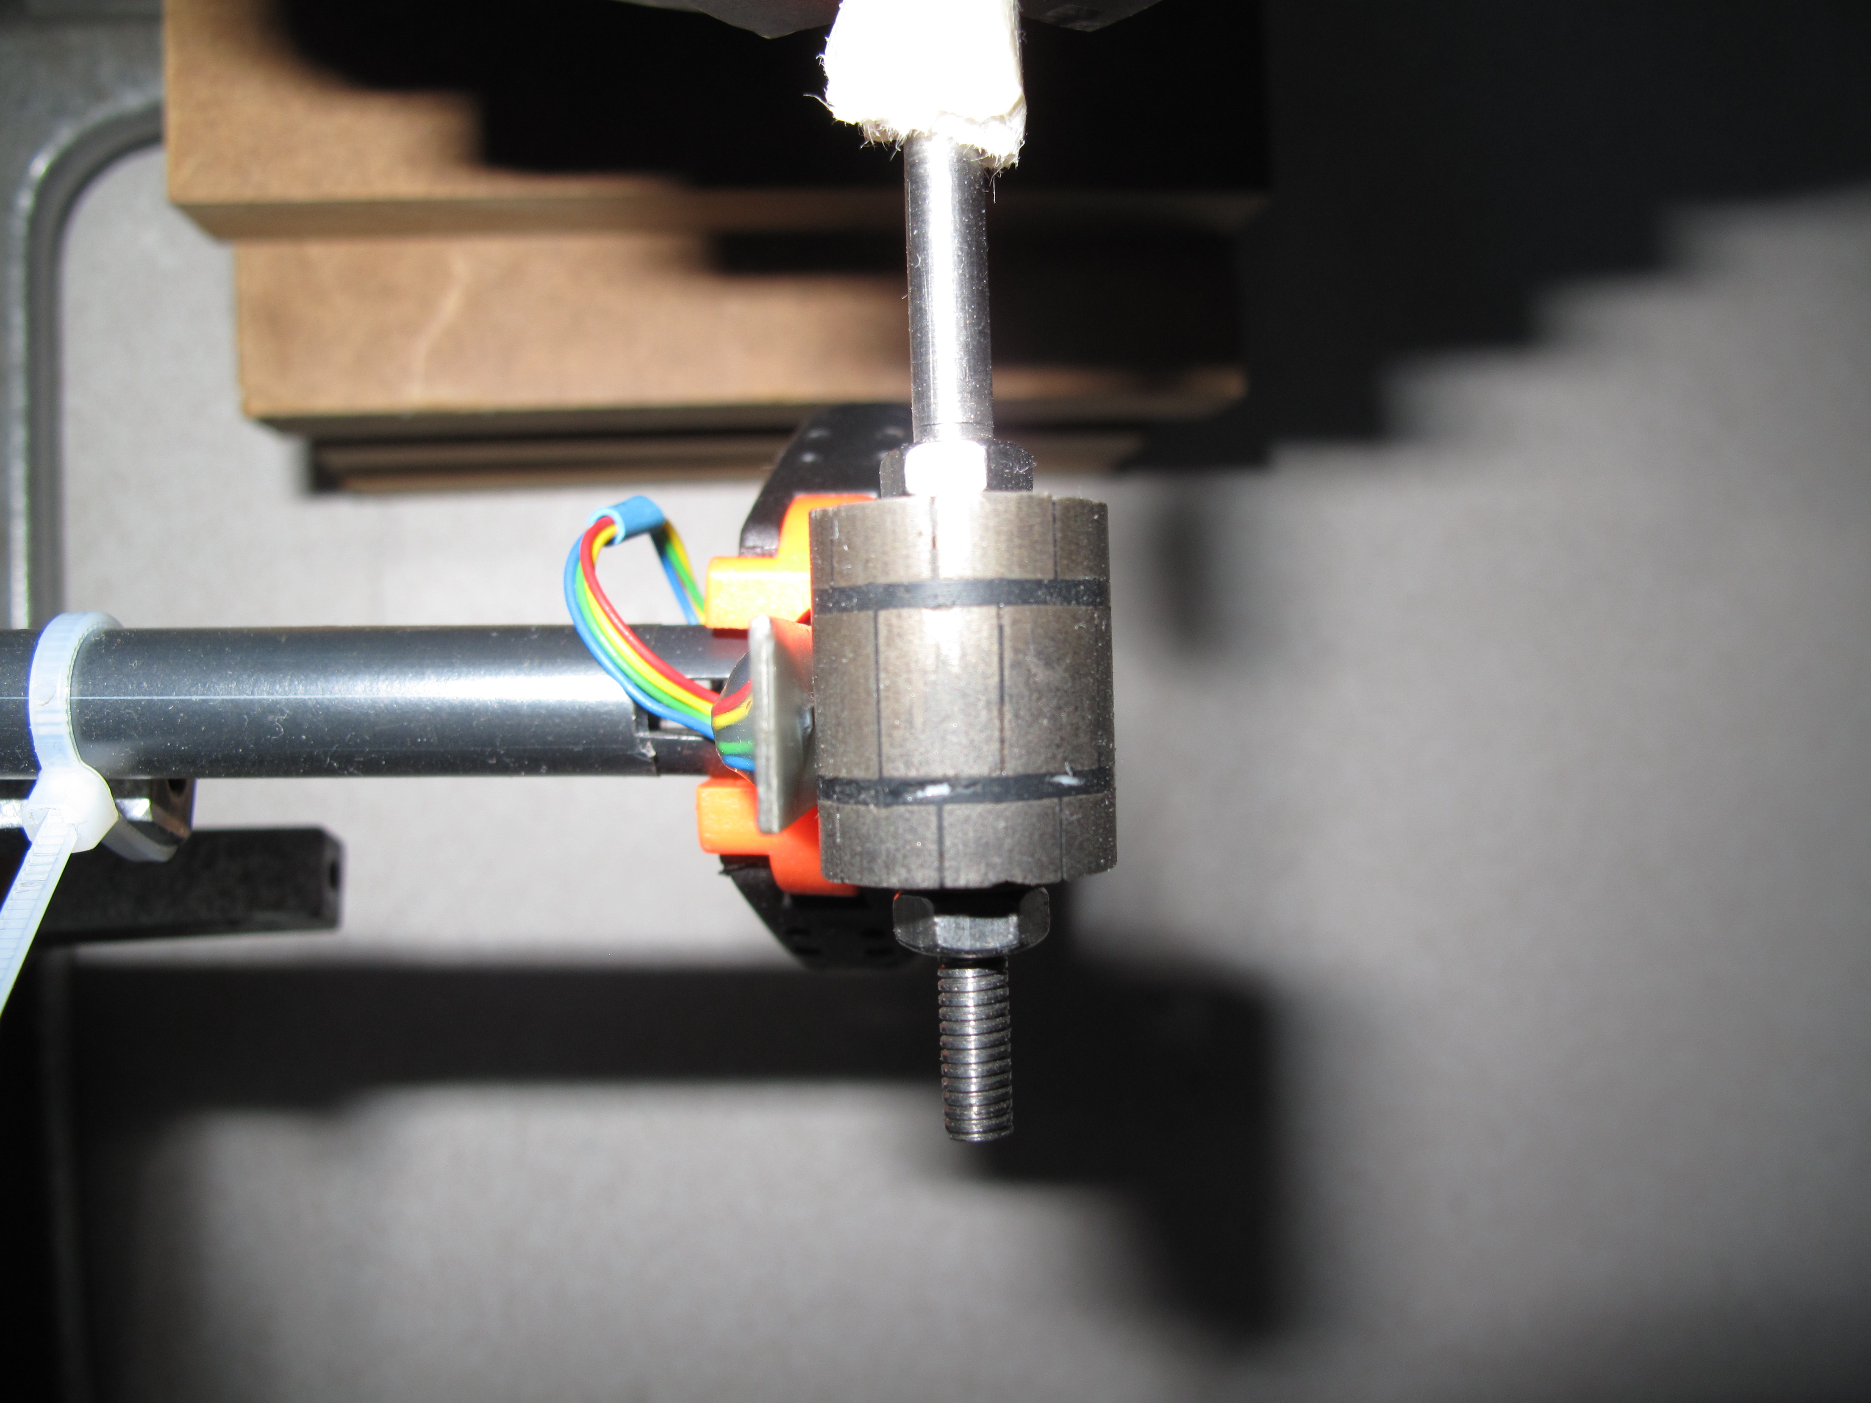
Figure 1. The Hall probe in contact with the magnet assembly.

A series of measurements were taken, along the z-axis and rotating the magnet assembly by 9º after each z series. Several times during this procedure the position of the Hall probe was checked to ensure close contact with the magnet surface. Parallel to the actual measurement of the field the magnet assembly was simulated using Maxwell 2D.

Figure 2. Flux lines from the magnet assembly as simulated by Maxwell 2D.

Conclusion

Careful measurements of the magnetic field strength and symmetry have been made using the magnet assembly from the failed target. No significant asymmetries were observed and good agreement was seen between the measurements and the model.

