Target DAQ Upgrade Plan

Introduction

The target DAQ is required to receive, process and record critical target data in order to ensure reliable and reproducible target operation. The key elements to the target operation are as follows:

Target position.
Target activation time.
ISIS beam status.
ISIS beam injection time.
ISIS beam position.
Target frame position.
Target coil temperatures.
Target cooling water temperature.
Target cooling water flow.
ISIS Beamloss, both total beamloss and sector beamloss.

The existing DAQ records some of the above data but as the control electronics are being redesigned it is necessary to also upgrade the DAQ.

The current target DAQ

The present DAQ system only records a subset of the above data and it does so in a fragmented fashion. Some of the parameters are recorded using the EPICS framework in particular the target frame position and coil temperatures. The main target operational parameters of position and time are recorded using an ADC card in a local DAQ PC and some of the required data is not available in the current system.

The Proposed Target Electronics Upgrade

There is a separate plan to redesign and upgrade the target control electronics which envisages the replacement of the current hybrid system with a fully integrated Field Programmable Gate Array (FPGA) based system (Ref. ). This proposed system will allow much enhanced control of the target with the front panel manual controls replaced by a PC based GUI control system. The timescale for this hardware upgrade is proposed to take place over 2009 with stage 1 replicating the existing system by June 2009 and stage 2 establishing full FPGA control by December 2009.

The DAQ upgrade plan

As the final design of the target DAQ will be driven by the inputs from the control electronics and the availability of signals from ISIS a precise plan cannot be formulated at the current time. When the FPGA based system is more concrete it will be possible to detail the exact way in which its output will be captured and displayed. Until then the following outline is proposed.
It is desirable to parameterize some of the main target operation data and to be able to present the evolution of this over time. For example a single target pulse looks like (see Fig. 1).

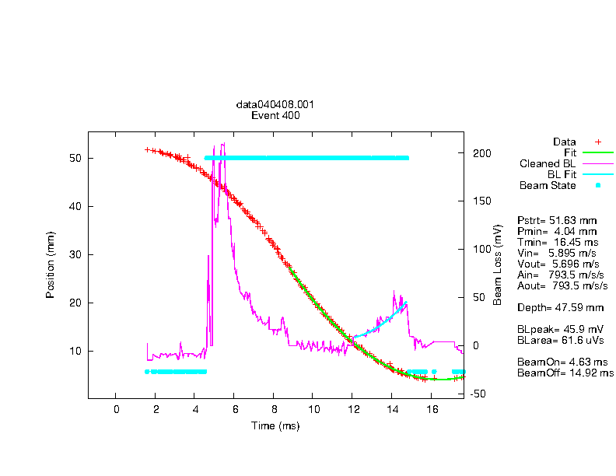
Figure 1. A typical target pulse showing the raw data and some parameterisation.

Each pulse can be parameterized giving:

Target start time
ISIS beam on
ISIS beam off
Minimum depth
Time of minimum depth
Target velocity
Target acceleration
Beamloss total
Beamloss in various sectors
An upgraded DAQ should be able to present these data as history plots showing their evolution over time. For example see figure 2. below showing the target displacement over time for a particular MICE run.

t
Figure 2. The history of the target depth for a specific run period.

Timescales

Note that any timescales are by necessity vague at this stage as the final concrete implementation of the DAQ depends heavily on the ultimate form of the new control system. It is however possible to propose a general outline.

Stage 1 Review and maintain existing DAQ for the MICE run period in 2009.

Stage 2 Finalize data set from system control redesign by December 2009.

Stage 3 Complete redesign of integrated DAQ by June 2010

